MID VIVA Figma Link

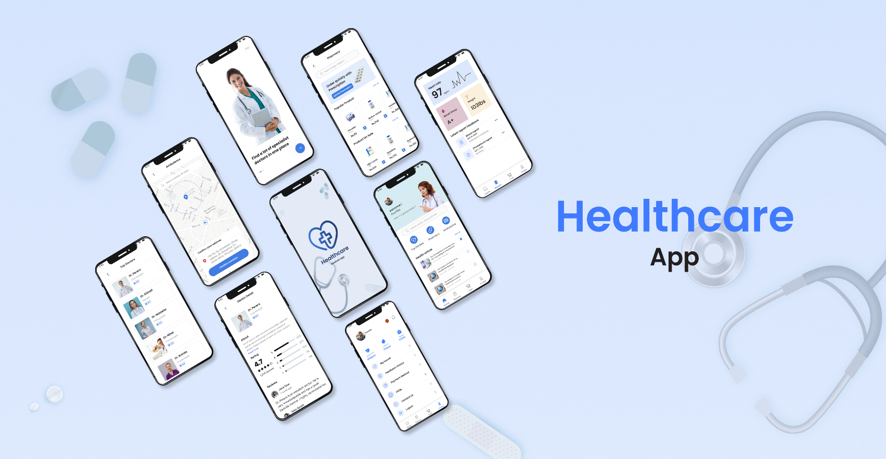

<https://www.figma.com/design/dPFzRCBVHJNGc3BVtZpJIB/Healthcare-app-(Community)?node-id=0-1&t=QTl7EmY8abkFNMdS-1>